American International University-Bangladesh (AIUB)  
**Department of Computer Science  
Faculty of Science & Technology (FST)**

**GYM STREAK**

A Software Requirement Engineering Project Submitted

By

|  |  |
| --- | --- |
| **Semester: Spring_22_23** | **Section:I** |
| Student Name | Student ID |
| Abdullah Yousuf Noman | 20-42130-1 |
| Ananna Rashid Kumkum | 20-43589-1 |

Software Test Plan

for

GYM STREAK

Version 1.0 approved

Prepared by

Samihatul Bari, Abdullah Yousuf Noman, Md.Tanvir Ahmed Noyan, Md. Tamim Karim, Ananna Rashid Kumkum.

American International University - Bangladesh

April 30, 2023

Table of Contents

Revision History 4

1. TEST PLAN IDENTIFIER: GS-TP01.5 5
2. REFERENCES 5
3. INTRODUCTION 5

3.1 Background to the Problem 5

3.2 Solution to the Problem 5

1. REQUEIREMNT SPECIFICATION 6
   1. System Features 6
   2. System Quality Attributes 8
   3. System Interface 8
   4. Project Requirements 10
2. FEATURES NOT TO BE TESTED 11
3. TESTING APPROACH 11
   1. Testing Levels 11
   2. Test Tools 12
   3. Meetings 13
4. TEST CASES/TEST ITEMS 13
5. TEM PASS/FAIL CRITERIA 19

Outlining the PASS/FAIL criteria for the tests contained in this project is the main objective of this part. If a system or unit receives a score between 92% and 96%, it will be regarded to have met the pass criterion, and if it receives a score below 80%, it will have failed. In order to assess how trustworthy and user-satisfying our project is, we employed this metric. 19

1. TEST DELIVERABLES 19
2. STAFFING AND TRAINING NEEDS 20

* The developers and testers will need to be taught Java, C++, Dart, Flutter, and MySQL. 20
* Automation tester should gain the proper knowledge and also have the experience to operate the tools. 20

1. RESPONSIBILITIES 20
2. TESTING SCHEDULE 21
3. PLANNING RISKS AND CONTINGENCIES 22
4. APROVALS 23

# Revision History

|  |  |  |  |
| --- | --- | --- | --- |
| Revision | Date | Updated by | Update Comments |
| 0.1 | 2023.04.01 | Ananna Rashid Kumkum | First Draft |
| 0.2 | 2023.04.6 | Abdullah Yousuf Noman | Second Draft |
| 0.3 | 2023.04.13 | Md.Tanvir Ahmed Noyan | Third Draft |
| 0.4 | 2023.04.16 | Samihatul Bari | Forth Draft |
| 0.5 | 2023.04.19 | Md. Tamim Karim | Fifth Draft |
| 0.6 | 2023.04.28 | Ananna Rashid Kumkum | Sixth Draft |
| 0.7 | 2023.04.30 | Abdullah Yousuf Noman | Seventh Draft |

# TEST PLAN IDENTIFIER: GS-TP01.5

# REFERENCES

L. Morgado, J. Varajão, D. Coelho, C. Rodrigues, C. Sancin, V. Castello, “The Attributes And Advantages Of Virtual Worlds For Real World Training,” The Journal Of Virtual Worlds And Education, 1 (1), 2010.

F. Cassola, L. Morgado, F. De Carvalho, H. Paredes, B. Fonseca, And P.Martins, “Online-Gym: A 3d Virtual Gymnasium Using Kinect Interaction,” Procedia Technology, 13, Pp. 130-138, 2014

World Health Organization. *Obesity and Overweight*; World Health Organization: Geneva, Switzerland, 2019.

Peeters, A.; Barendregt, J.; Willekens, F.; Mackenbach, J.; Al Mamun, A.; Bonneux, L. Obesity in adulthood   
and its consequences for life expectancy: A life-table analysis. *Ann. Int. Med.* **2003**, *138*, 24–32.

# INTRODUCTION

## 3.1 Background to the Problem

We live in a society where we have to multitask. Have so many work to do. Therefor don’t give enough attention to our fitness and health routine. If we do there is hassle of need for going to the gym, give lot of time on which item we have to eat, if we want to do exercise in home there is less equipment available and there is no proper exercise an individual know except for running and walking. We became so busy that we want to eat fast and heavy food which are tasty. In that case we eat fast food. For this our average weight is gaining and healthy condition in going down compare to our ancestor.

## 3.2 Solution to the Problem

We are creating a software in which a person will give his hight and weigh his/her desired weight goal. There will be short video foe each part of body exercise such as arms, shoulder, chest, back, abs, legs. In which day which exercise will be done. There will be an option for at home or at gym. That person can also buy gum instrument for creating a home gym. Now comes the diet section. There that person will get which food in which amount he/she has to eat. The person can also buy the foods which will keep them healthy and fit. There will be supplement section also and gym accessories.

The software is mainly for keeping a good health by keeping body fit and with proper diet. And to purchase the goods to get the result.

There are many software available but there is only gym exercise or home workout separately. There is diet plan individually. And for purchase there is another software. But with in this app all the things will be in one software. So it will be easy to use and the user will get the goods easily.

# REQUEIREMNT SPECIFICATION

## System Features

**1. System Login**

Functional Requirements  
1. The software shall allow users to login with their given username and password

1. If the username and/or password has been inserted wrong for more than three &mes, the random verificaton code will be generated by the system to retry login.
2. If the number of login attempt exceed its limit (5 &mes), the system shall block the user account login for one hour [optional functon]

Priority Level: High  
Precondition: user have valid user id and password

Cross reference: 4.1, 7.2

**2. Registration Session**

Functional Requirements

1. User will enter their personal information such as name, phone number, age, gender, hight, weight and enter a password so that after registration they can use the name and password as login information.

2. Systemwillverifyisthereanyaccountexistonthisnumber.Ifthereisnoaccountonthis number, an OTP is sent to this phone number. Otherwise, registrations won’t happen.

Priority level: High

Cross reference: 4.2, 7.1

**3. Workout Session**

Functional Requirements

* + - * 1. User will put the information if he want to workout at home or at gym. There will be different types of exercise based on that selection.
        2. Which day which exercise needs to be done, what has to be eaten before or after workout system will automatically give that
        3. The progress in workout via a smartwatch or smart band.

Priority level: High

Cross reference: 4.3, 7.5

**4. Diet Session**

Functional Requirements

User will see how many times he/she have to eat which time, which amount of food.

Which supplements will suite the best according to users body weight and progressing.

Notify the user when it’s time to drink via notification.

Priority level: High

Cross reference: 4.4, 7.6

**5. Food Order**

Checking food searching process.

* User will enter the food name in the search bar, there will appear all foods of this name or all foods of this restaurant with details.
* Priority Level: Medium.

Add to cart

* When user click the cart button at the top of the page, there will appear the selected food list.
* Priority Level: Medium. Confirm order
* When user will Go to the cart, select amount and click conform order , it will go to the payment page.

Priority Level: Medium.

Cross reference: 4.5, 7.7

**6. Update Info**

Functional Requirements:

* + - * Validate user input to ensure accuracy and data integrity.
      * Save updated information to the database or storage system for data consistency and availability.

Priority Level: High

Preconditions: User has valid data

Cross reference: 4.6, 7.3

**7. Check Info**

Functional Requirements:

* + - * Verify user identity through secure and reliable process to grant access of Bkash payment.
      * Ensure accuracy and up-to-date information to provide reliable and trustworthy data to users.

Priority Level: Medium

Preconditions: Database should consist of all Bkash user info

Cross reference: 4.7, 7.4

**8. Delete Info**

Functional Requirements:

* + - * Ensure only authorized personnel can delete information.
      * Remove data accurately and efficiently without affecting related data.

Priority Level: Low

Cross reference: 4.8, 7.8

## System Quality Attributes

* Performance: The gym system should be able to handle high volumes of traffic and requests from users, ensuring that users can access the system quickly and easily.
* Availability: The gym system should be available at all times, ensuring that users can access it whenever they need it.
* Reliability: The gym system should be reliable and stable, with a low rate of errors or crashes, ensuring that users can trust it and depend on it.
* Security: The gym system should be secure, protecting users' personal information and ensuring that unauthorized access to the system is prevented.
* Usability: The gym system should be easy to use, with a user-friendly interface and intuitive navigation, ensuring that users can quickly and easily find the information and features they need.
* Scalability: The gym system should be able to scale up or down as needed, to handle changes in user demand or changes in the system's requirements.
* Flexibility: The gym system should be flexible, allowing for customization and configuration to meet the specific needs of different gym.
* Interoperability: The gym system should be able to integrate with other systems and technologies, such as payment processing systems, to ensure a seamless user experience.

## System Interface



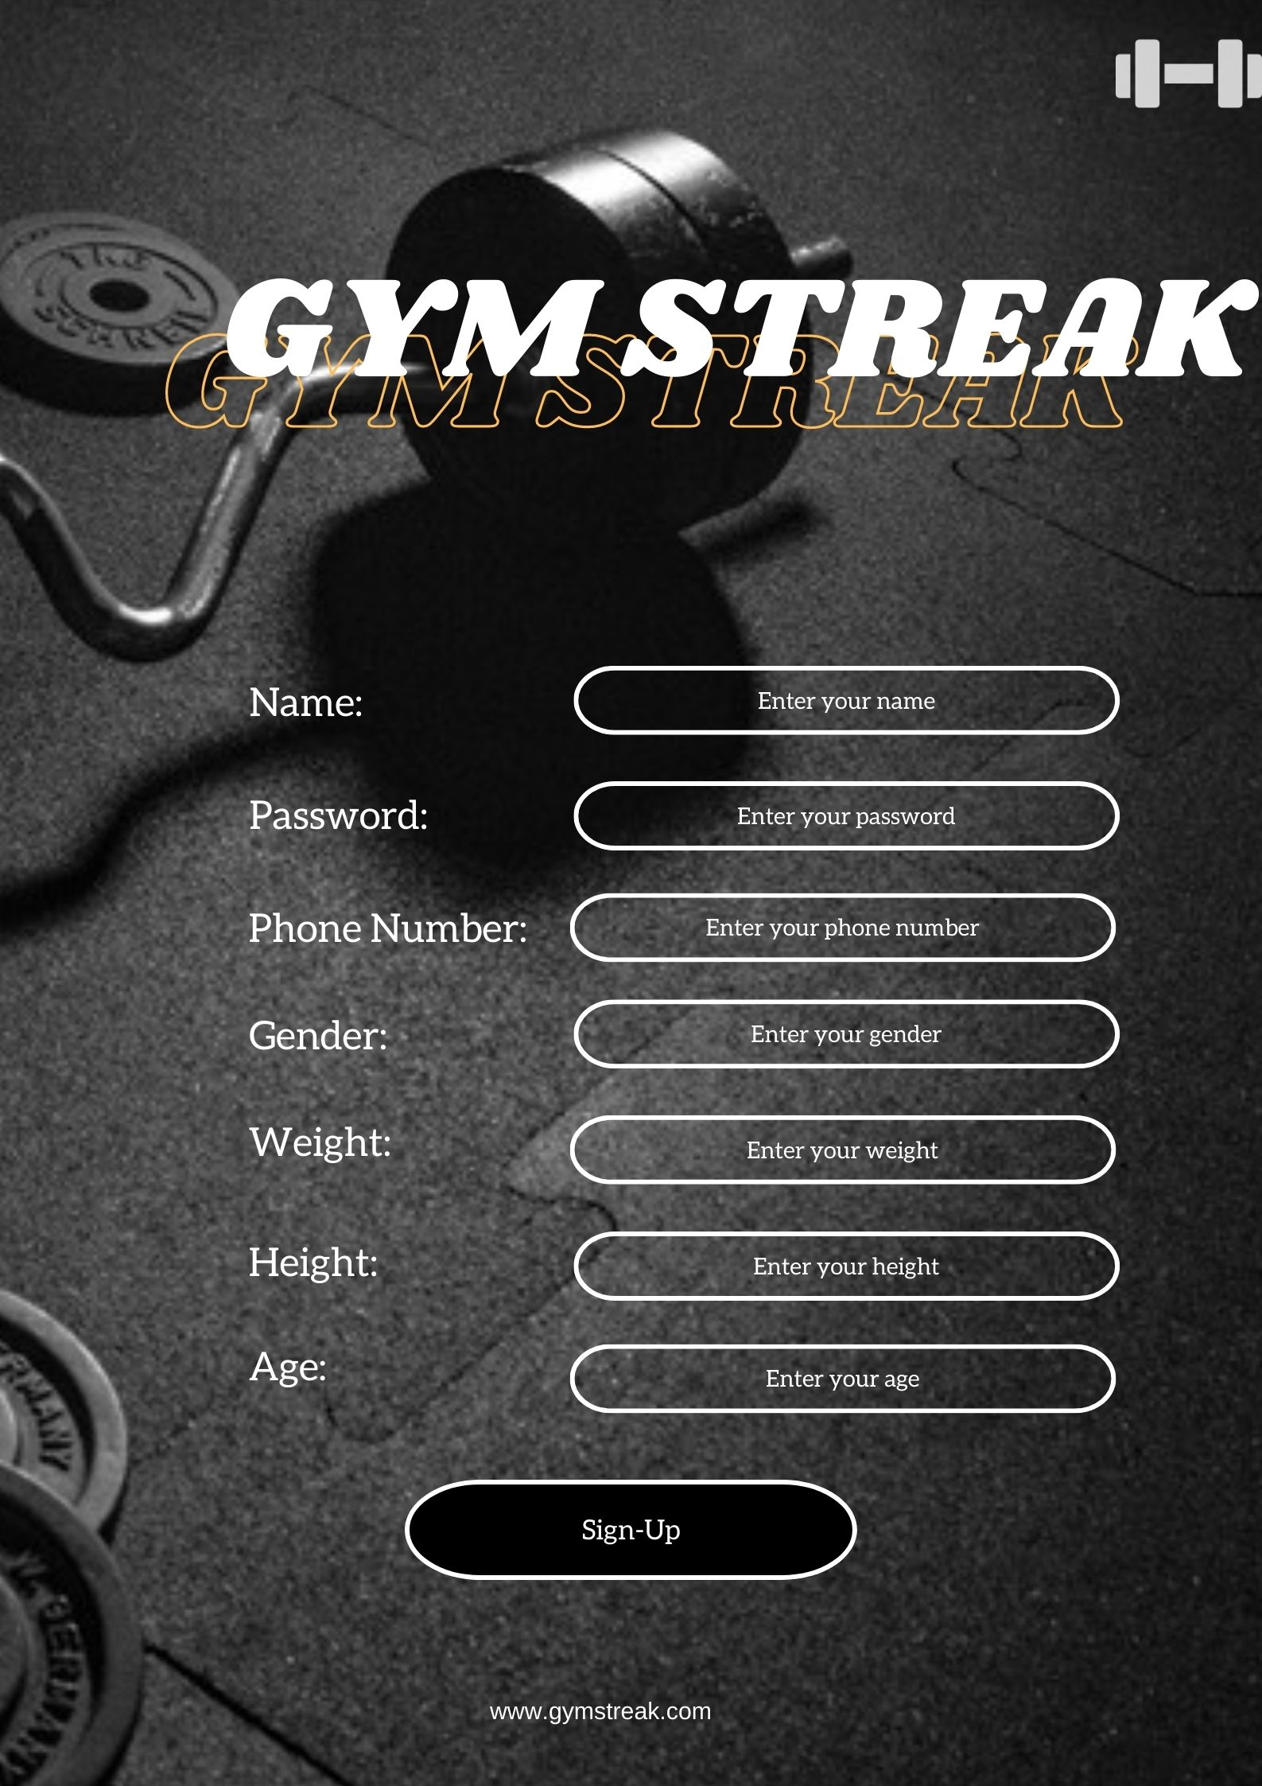

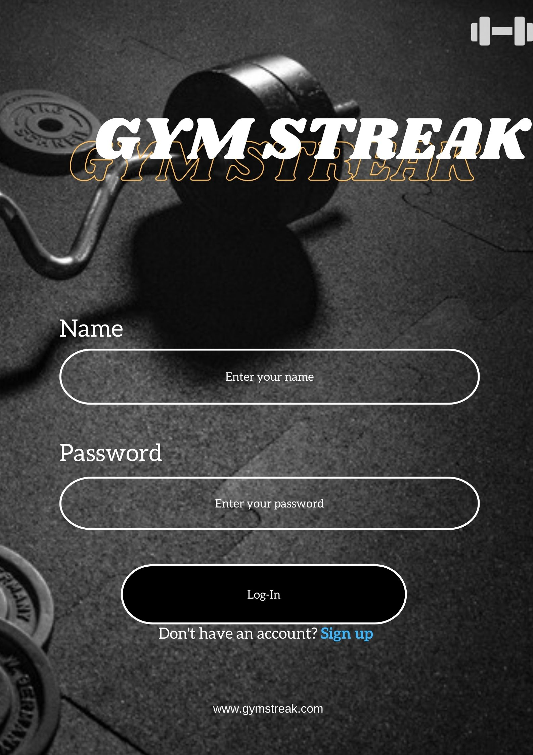

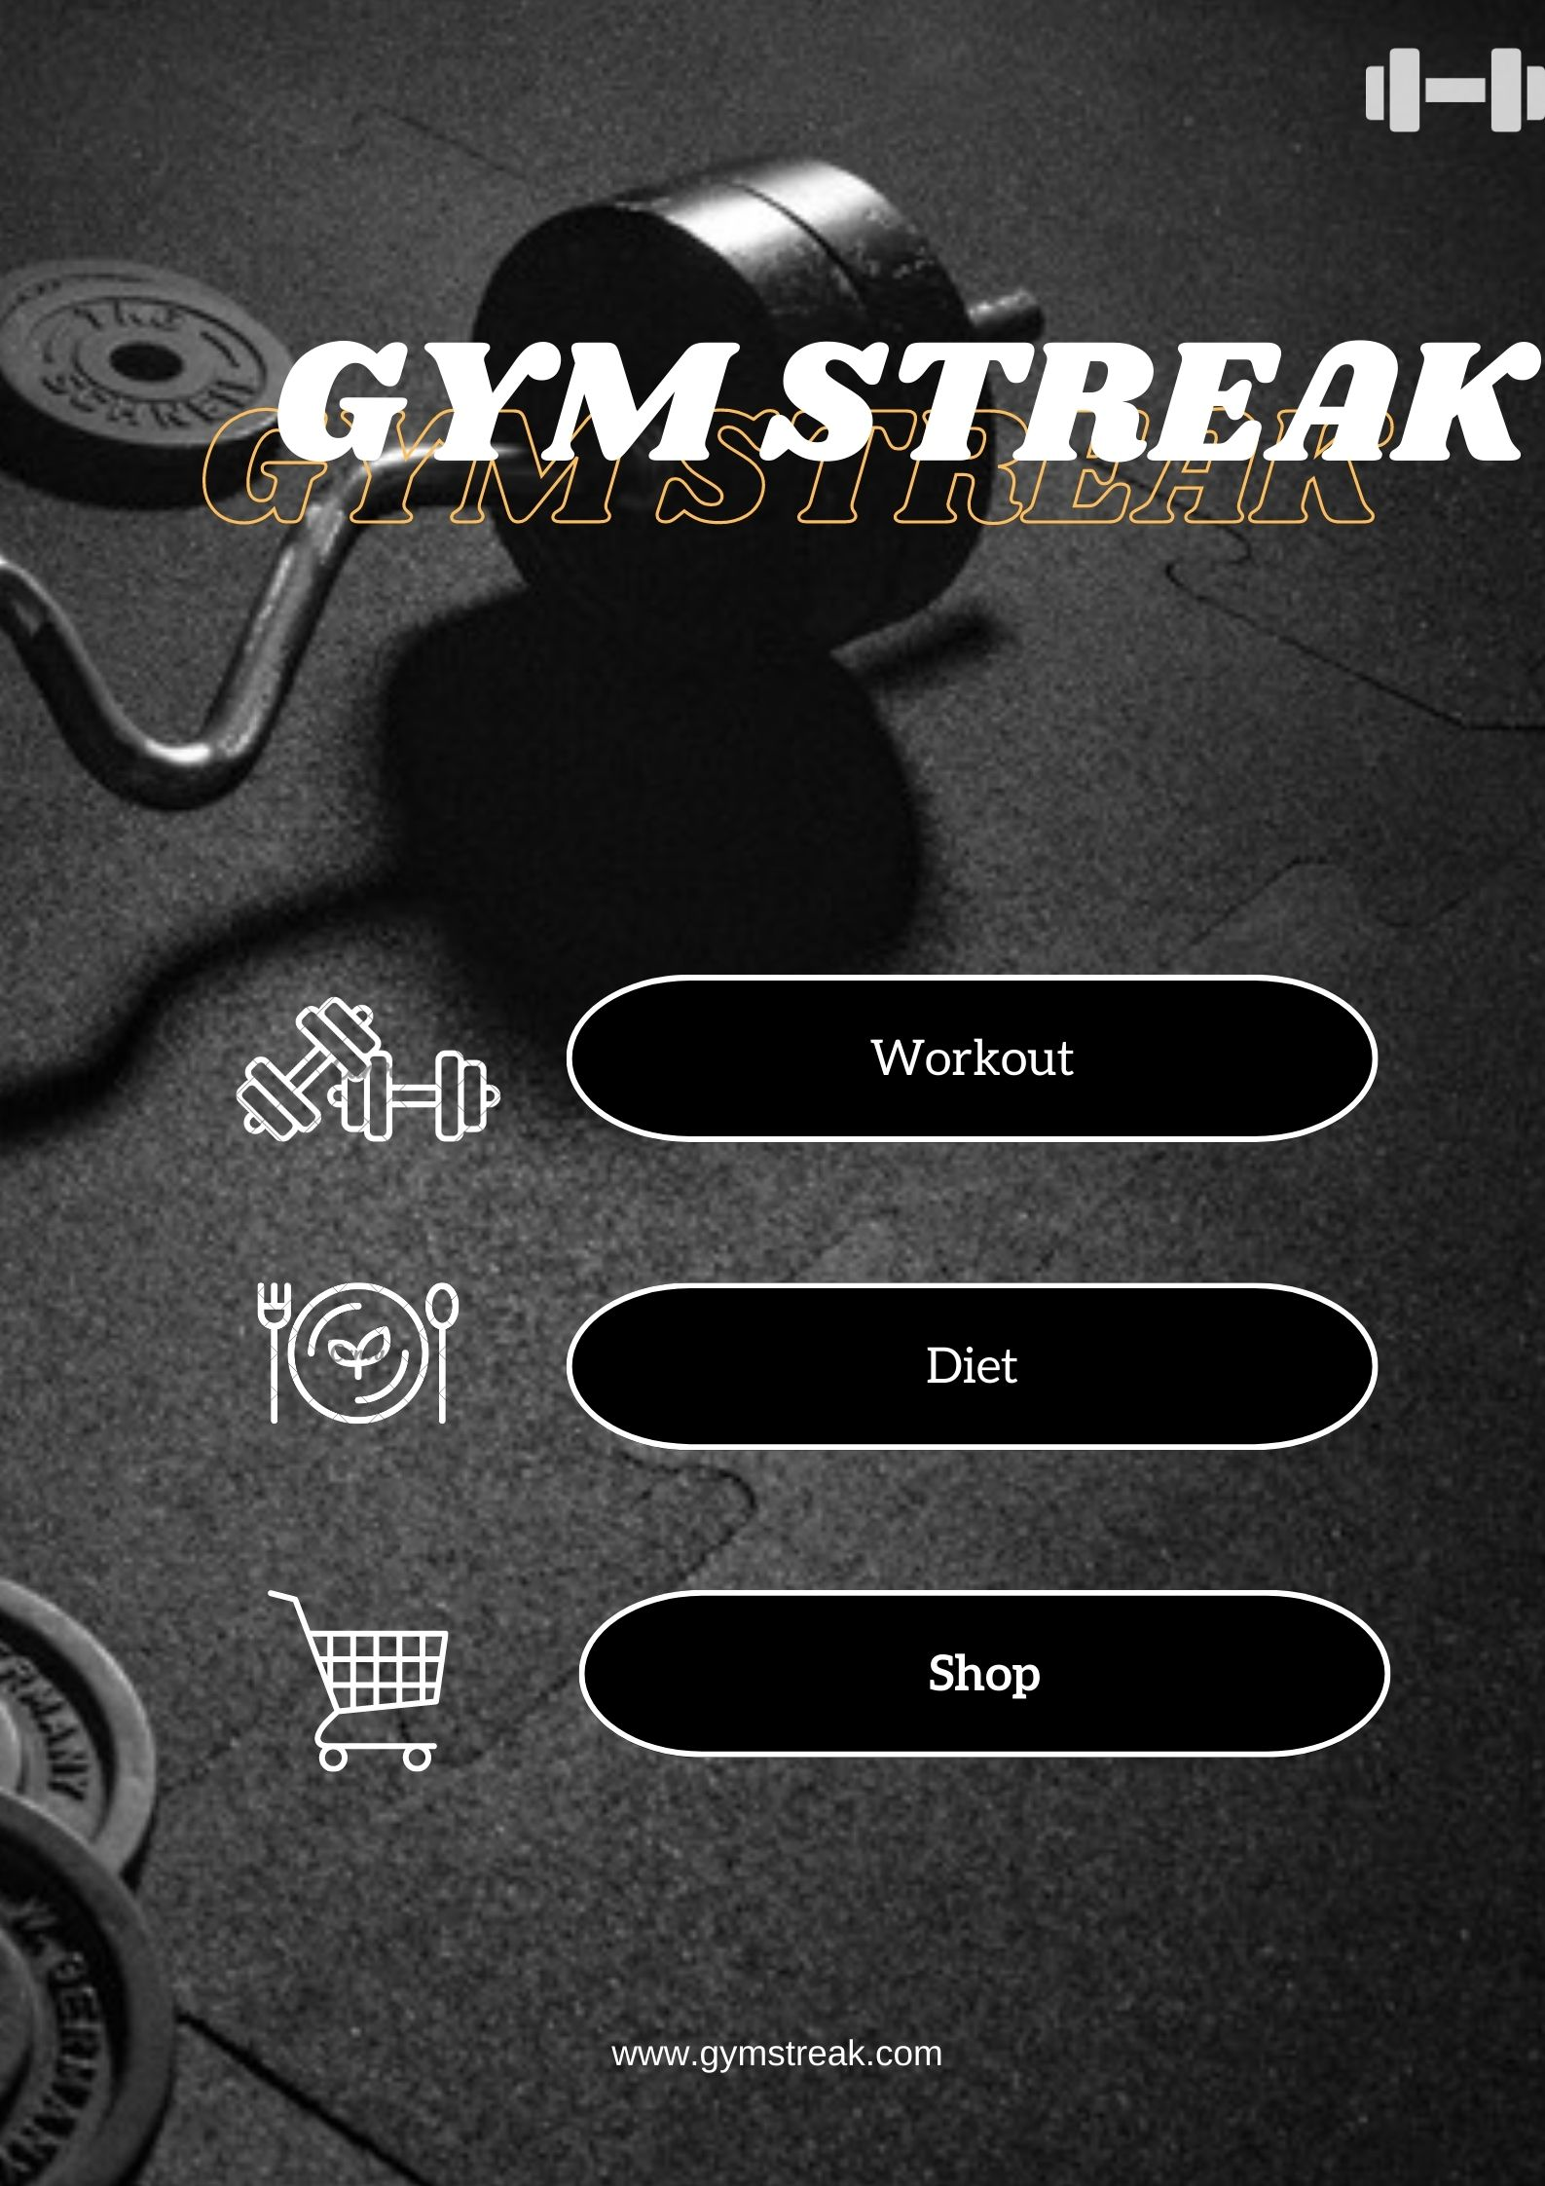

## Project Requirements

Our primary goal in project is to ensure timely delivery of the product within the specified budget while maintaining the required level of quality. However, various challenges such as time, cost, scope, resources, and environment need to be managed effectively to achieve success. It is essential to complete the project within the deadline, on schedule, and within the allocated budget while ensuring the necessary functionality is added to the system. Proper management of resources is also crucial. Successfully addressing each constraint will lead to a favourable outcome.

**Time**: The project must be completed within the specified timeline and any delays should be minimized.

To develop a prototype of the software, 100 hours of work are required, while for the development phase, 500 hours are needed. Revision of the software will require 80 hours, and testing and debugging will take approximately 220 hours. In total, 900 hours of work will be required. Assuming a daily work schedule of 12 hours, the project can be completed in approximately 45 days, which is equivalent to 2.5 months or 10 weeks.

**Budget**: The project must be completed within the allocated budget and any additional costs should be kept to a minimum.

Total budget 3,00,000 BDT

**Security**: The project must comply with all relevant security guidelines and regulations to ensure that the system is secure and protected from unauthorized access.

**Customization**: The system must be customizable to meet the specific needs of different tourism organizations.

**Usability**: The system must be user-friendly, intuitive, and easy to use to ensure that users can quickly and easily complete their tasks.

**Maintenance and support:** The system must be designed to be easy to maintain and supported to ensure that any issues can be quickly and efficiently resolved.

# FEATURES NOT TO BE TESTED

The following is a list of the areas that will not be specifically addressed. All testing in these areas will be indirect as a result of other testing efforts.

1. Database server management
2. Maintaining web service
3. Data entry
4. Network security

# TESTING APPROACH

## Testing Levels

**Unit Testing**:

System Login

Registration Session

Workout Session

Diet Session

Food Order (Checking food searching process)

**Integration Testing**:

Registration Session

Workout Session

Food Order (Add to cart)

**System Testing**:

System Login

Food Order (Confirm order)

**Acceptance Testing:**

All system features

**Regression Testing:**

All system features

## Test Tools

* Selenium: This tool can be used for automated testing of the web-based software application. Selenium can be used to test the functionality of the website, including the navigation, user interface, and other functionalities.
* Appium: Appium is an open-source tool for mobile app testing, which can be used for testing the mobile app version of this software.
* JMeter: JMeter is a performance testing tool that can be used to test the scalability and stability of the software. It can be used to simulate user traffic and measure response time.
* TestComplete: This tool is ideal for testing the GUI of the desktop, mobile, and web applications, which can be used for testing the user interface of this software application.
* Postman: Postman is a popular tool used for API testing, which can be used for testing the APIs of this software application.
* LoadRunner: This tool can be used for performance testing of enterprise-level applications. LoadRunner can be used to simulate user traffic and measure response time, which is useful for testing the scalability and stability of the software.
* TestRail: This tool can be used for test management, including test case management and test execution reporting. It can be used to manage the testing process of this software application.
* Katalon Studio: This integrated automation testing tool can be used for testing web, mobile, API, and desktop applications. It is useful for testing the functionality and user interface of the software application.
* For unit testing, we can use Selenium or TestComplete.
* For integration testing, we can use Selenium, Appium, or TestComplete.
* For system testing, we can use JMeter or LoadRunner.
* For acceptance testing, we can use TestRail or Katalon Studio.

## Meetings

Our testing team convenes weekly to discuss their progress, challenges, work status, and ideas for enhancing the testing process. Such meetings are crucial to improving functionality, error detection, and feasibility testing. Every two weeks, the testing team lead or supervisor reviews the progress to ensure that it aligns with user requirements and maintains high quality standards. Consistent monitoring and supervision are essential to achieving maximum quality. In emergency situations, additional meetings may be held as required. Testers should communicate their challenges and progress with one another. From home, employees may participate in live chat sessions to discuss new developments and ideas for enhancing functionality before scheduled meetings. The team lead collaborates with various teams and their progress and keeps in constant touch with them through regular meetings.

# TEST CASES/TEST ITEMS

|  |  |  |  |  |  |
| --- | --- | --- | --- | --- | --- |
| Project Name: Gym Streak | | | Test Designed by: | | |
| Test Case ID: GS_1 | | | Test Designed date: 24 March, 2023 | | |
| Test Priority (Low, Medium, High): High | | | Test Executed by: Ananna Rashid Kumkum | | |
| Module Name: SignUp | | | Test Execution date: 27 March, 2023 | | |
| Test Title: Sign up with valid user name, phone number, password, Hight, Weight, Gender, Age | | |  | | |
| Description: Test the application sign up page | | |  | | |
| Precondition (If any): User must have valid user name, phone number, password, Hight, Weight, Gender, Age. | | | | | |
| Test Steps | Test Data | Expected Results | | Actual Results | Status (Pass/Fail) |
| 1. Go for sign up 2. Enter user name 3. Enter Age 4. Enter phone number 5. Enter Gender 6. Enter password 7. Hight 8. Weight 9. Click submit | User name: Tonmoy  Age: 21  Phone Number: 01795412919  Gender: Male  Hight: 6’  Weight: 85kg  Password: Rock001 | User should sign up successfully. | | As expected, | Pass |
| Post Condition: user is validated with the database and successfully sign up to account. | | | | | |

|  |  |  |  |  |  |
| --- | --- | --- | --- | --- | --- |
| Project Name: Gym Streak | | | Test Designed by: | | |
| Test Case ID: GS_2 | | | Test Designed date: 24 March, 2023 | | |
| Test Priority (Low, Medium, High): High | | | Test Executed by: Ananna Rashid Kumkum | | |
| Module Name: LogIn | | | Test Execution date: 27 March, 2023 | | |
| Test Title: Verify log in with valid user name and password | | |  | | |
| Description: Test the application login page | | |  | | |
| Precondition (If any): User has valid user name and password | | | | | |
| Test Steps | Test Data | Expected Results | | Actual Results | Status (Pass/Fail) |
| 1. Go for login 2. Enter user name 3. Enter password 4. Click submit | User name: Tonmoy  Password: Rock001 | User should log in into the application | | As expected, | Pass |
| Post Condition: user is validated with the database and successfully log in to account. The account session details are logged in the database. | | | | | |

|  |  |  |  |  |  |
| --- | --- | --- | --- | --- | --- |
| Project Name: Gym Streak | | | Test Designed by: | | |
| Test Case ID: GS_3 | | | Test Designed date: 30 March, 2023 | | |
| Test Priority (Low, Medium, High): High | | | Test Executed by: Abdullah Yousuf Noman | | |
| Module Name: Update info | | | Test Execution date: 4 April, 2023 | | |
| Test Title: Update user info | | |  | | |
| Description: Test the application update info page | | |  | | |
| Precondition (If any): User has valid data | | | | | |
| Test Steps | Test Data | Expected Results | | Actual Results | Status (Pass/Fail) |
| 1. Go for update 2. Enter update name 3. Enter update password 4. Enter update phone 5. Enter Update Weight 6. Enter Update age 7. Click submit | User name: Max  Password: E2max1  Phone: 01975412919  Weight: 82kg  Age: 22 | User should update his information | | As expected, | Pass |
| Post Condition: user is validated with the database and successfully update. | | | | | |

|  |  |  |  |  |  |
| --- | --- | --- | --- | --- | --- |
| Project Name: Gym Streak | | | Test Designed by: | | |
| Test Case ID: GS_4 | | | Test Designed date: 30 March, 2023 | | |
| Test Priority (Low, Medium, High): Medium | | | Test Executed by: Abdullah Yousuf Noman | | |
| Module Name: See the Bkash user info | | | Test Execution date: 4 April, 2023 | | |
| Test Title: Test the Bkash user info | | |  | | |
| Description: Test the application update info page | | |  | | |
| Precondition (If any): Database should consist all Bkash user info | | | | | |
| Test Steps | Test Data | Expected Results | | Actual Results | Status (Pass/Fail) |
| 1. Go for check general info 2. Click search option on Bkash user | N/A | Fetch all data and make it visible | | As expected, | Pass |
| Post Condition: Database should consist of all Bkash user info | | | | | |

|  |  |  |  |  |  |
| --- | --- | --- | --- | --- | --- |
| Project Name: Gym Streak | | | Test Designed by: | | |
| Test Case ID: GS_5 | | | Test Designed date: 30 March, 2023 | | |
| Test Priority (Low, Medium, High): High | | | Test Executed by: Abdullah Yousuf Noman | | |
| Module Name: See the Gym Instruction | | | Test Execution date: 4 April, 2023 | | |
| Test Title: Test the Gym instruction | | |  | | |
| Description: Test which day which body part to exercise | | |  | | |
| Precondition (If any): Database should consist Gym exercise info | | | | | |
| Test Steps | Test Data | Expected Results | | Actual Results | Status (Pass/Fail) |
| 1. At home or at Gym 2. Day | In Gym  Sunday- Arms | Showing arms exercise | | As expected, | Pass |
| Post Condition: Database should consist of Gym exercise info | | | | | |

|  |  |  |  |  |  |
| --- | --- | --- | --- | --- | --- |
| Project Name: Gym Streak | | | Test Designed by: | | |
| Test Case ID: GS_6 | | | Test Designed date: 30 March, 2023 | | |
| Test Priority (Low, Medium, High): High | | | Test Executed by: Abdullah Yousuf Noman | | |
| Module Name: See the Diet | | | Test Execution date: 4 April, 2023 | | |
| Test Title: Test the diet section | | |  | | |
| Description: Test which day which food to eat, which amount for the day | | |  | | |
| Precondition (If any): Database should consist all the diet info | | | | | |
| Test Steps | Test Data | Expected Results | | Actual Results | Status (Pass/Fail) |
| 1. Day 2. Morning | Sunday  2 Eggs, 1L water, Juice, 2 bread. | Showing the meal | | As expected, | Pass |
| Post Condition: Database should consist of diet info | | | | | |

|  |  |  |  |  |  |
| --- | --- | --- | --- | --- | --- |
| Project Name: Gym Streak | | | Test Designed by: | | |
| Test Case ID: GS_7 | | | Test Designed date: 30 March, 2023 | | |
| Test Priority (Low, Medium, High): High | | | Test Executed by: Abdullah Yousuf Noman | | |
| Module Name: See the Shop Info | | | Test Execution date: 4 April, 2023 | | |
| Test Title: Test the shop how to buy | | |  | | |
| Description: Test the shop, how to buy, add to cart , items | | |  | | |
| Precondition (If any): Database should consist the items | | | | | |
| Test Steps | Test Data | Expected Results | | Actual Results | Status (Pass/Fail) |
| 1. Go to shop 2. Select the item 3. Add to cart 4. Payment 5. Address 6. Submit | Nitro Tech 2Lb  3990tk  Bkash  Kuril, school road | Showing the teams, and price, payment option, address. | | As expected, | Pass |
| Post Condition: Database should consist of all the items info | | | | | |

|  |  |  |  |  |  |
| --- | --- | --- | --- | --- | --- |
| Project Name: Gym Streak | | | Test Designed by: | | |
| Test Case ID: GS_8 | | | Test Designed date: 30 March, 2023 | | |
| Test Priority (Low, Medium, High): Low | | | Test Executed by: Abdullah Yousuf Noman | | |
| Module Name: Delete account | | | Test Execution date: 4 April, 2023 | | |
| Test Title: Test the account deletion | | |  | | |
| Description: Test the deletion of an user id | | |  | | |
| Precondition (If any): N/A | | | | | |
| Test Steps | Test Data | Expected Results | | Actual Results | Status (Pass/Fail) |
| 1. Go for delete 2. Name 3. Password 4. Submit | Max  E2max1 | Should delete the id | | As expected, | Pass |
| Post Condition: User must have necessary permissions and authorization to access and delete function | | | | | |

# TEM PASS/FAIL CRITERIA

# Outlining the PASS/FAIL criteria for the tests contained in this project is the main objective of this part. If a system or unit receives a score between 92% and 96%, it will be regarded to have met the pass criterion, and if it receives a score below 80%, it will have failed. In order to assess how trustworthy and user-satisfying our project is, we employed this metric.

# TEST DELIVERABLES

* The audience for an acceptance test should be carefully selected because unreliable testers can produce inaccurate results and feedback. It functions as a contract for the release of the development team and the delivery of software.
* System integration modules, test strategies and results should all be documented. It is necessary to highlight COTS and third-party integration. The tolerance level of the OTS and the functionality of the component should be appropriately stated. DRE, PhAge, Spoilage, and other calculations for system testing should be calculated and documented prior to software delivery to enable QA improvement and effort easy to understand.
* Unit test findings and result should be documented properly. Product should be analyzed properly to help post testing. Turnover document must be ready.
* Screen-based prototyping concepts and software system toolkits should be incorporated in the text. It aids in understanding software operation as well as any hazards or difficulties. It is used to describe the completion of requirements to the end user.
* Mockup reports must be completed prior to project delivery in order to offer a model, visual draft of what the project will look like or how the design was originally envisaged. Different formats for charts, graphs, and illustrations can be used to allow readers to view the entire piece without having to scroll back and forth.
* Incident reports should be prepared in order to keep employees safe and to ensure that best practices are developed in the workplace during the project in order to improve the industry/organization grade and ensure a successful project. In our project, we created a comprehensive summary and report.
* The test log is a record of events that occurred throughout a test schedule and execution, as well as the status of each phase. We revised every phase and recorded data that explains actions and different approaches in the project.

# STAFFING AND TRAINING NEEDS

It is advised that this project have at least one full inspector due to the structure and stages of project distribution. For the assessment, the person will need to be given some time at the beginning of the project, and then, roughly six months later, they will need to be provided full-time. The project/test manager will take over if a different tester is not available. To include a thorough and pertinent study, the following preparation-related topics should be considered. The personnel for this project have long been planned. The majority of the group will participate in particular research tasks, which are covered in greater depth in the section on responsibilities.

# The developers and testers will need to be taught Java, C++, Dart, Flutter, and MySQL.

# Automation tester should gain the proper knowledge and also have the experience to operate the tools.

* The developers and tester(s) will need to be trained on the basic operations of the EDI interface. Prior to final acceptance of the project the operations staff will also require complete training on the EDI communications process.
* The sales administration staff will require training on the new screens and reports.

# RESPONSIBILITIES

|  |  |  |  |  |  |
| --- | --- | --- | --- | --- | --- |
|  | TM | PM | DevTeam | Test Team | Client |
| Acceptance test Documentation & Execution | X | X |  | X | X |
| System/Integration test Documentation & Exec. | X |  | X | X |  |
| Unit test documentation & execution | X |  | X | X |  |
| System Design Reviews | X | X | X | X | X |
| Detail Design Reviews | X | X | X | X |  |
| Test Procedures and rules | X | X | X | X |  |
| Screen & Report Prototype reviews |  |  | X | X | X |
| Change control and Regression testing | X | X | X | X | X |

# TESTING SCHEDULE

Time has been allocated within the project plan for the following testing activities. The specific dates and times for each activity are defined in the project plan timeline. The persons required for each process are detailed in the project timeline and plan as well. Coordination of the personnel required for each task, test team, development team, management and customer will be handled by the project manager in conjunction with the development and test team leaders.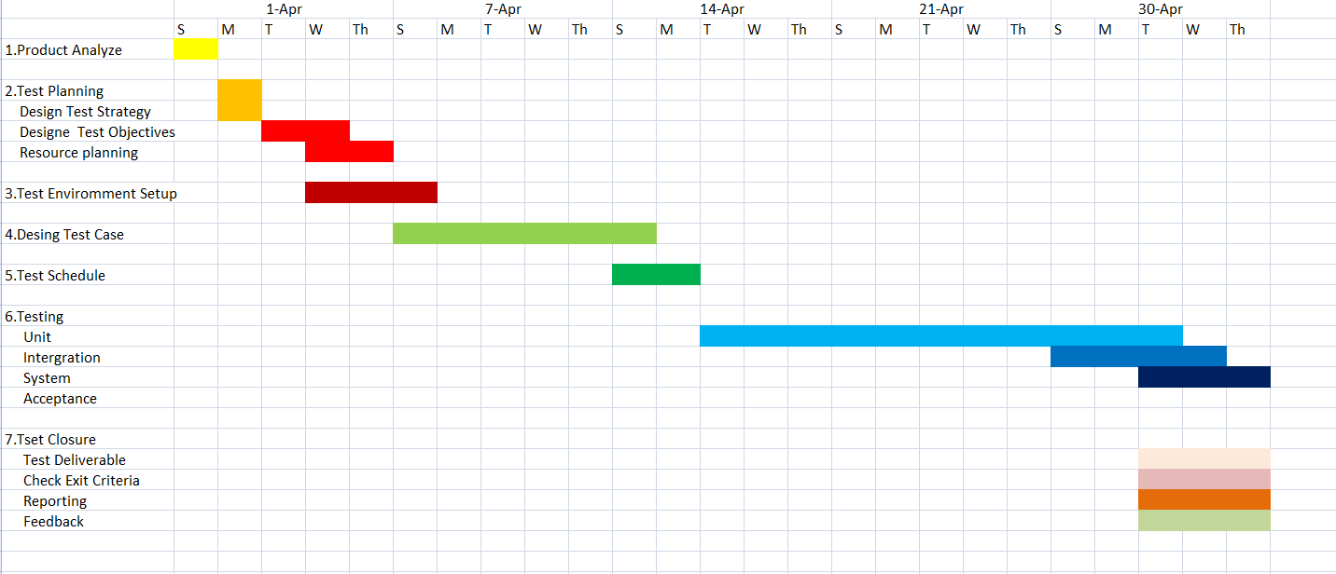

# PLANNING RISKS AND CONTINGENCIES

|  |  |  |  |  |
| --- | --- | --- | --- | --- |
| **S/N** | **Risk Description** | **Probability** | **Impact** | **Mitigation Plan** |
| 1 | Account security | 20% | Moderate | Allow users to enter 5 times to  enter incorrect password. |
| 2 | Online Payment Security | 30% | Significant | Allow users to enter 3 times to  enter incorrect pin. |
| 3 | Unable to acquire required hardware for  testing | 5% | Low | Start testing after making sure all the required hardware are  available. |
| 4 | Exceeding budget | 60% | High | Take some extra money from  client for safety. |

# APROVALS

|  |  |
| --- | --- |
| Project Sponsor | Approved |
| Development Management | Approved |
| EDI Project Manager | Approved |
| RS Test Manager | Approved |
| RS Development Team Manager | Approved |
| Reassigned Sales | Approved |
| Order Entry EDI Team Manager | Approved |